Introduction to Computer Organization – Fall 2025

Lab 1
Due: @11:55 pm, Sunday August 31st via Gradescope
(You need to indicate where your answers are located on Gradescope to receive credit)
Future assignments must be completed in lab and submitted in-person to receive credit

The following assignment is intended to be completed during your assigned lab period. One member of your group must submit the assignment to Gradescope by the posted deadline and indicate your group members when submitting the assignment.

Group names and uniqnames

Name | Uniqname
Kowei Huang | hkowei
Gao Shenghan | shenghan
Jiang Heshun | jhsbzd

Problem 1: Conversion from Binary [12 points]

Convert the following Binary into Decimal, Hex, and Octal.

Binary: 0101 1010 1101

Decimal: 1453________

Hexadecimal: 5AD__________

Octal: (for fun... not graded) _2655______
For the next problem, you will need to set up your IDE.

Then, download the starter code for Lab 1:
wget https://eecs370.github.io/labs/lab1.tar.gz
When you finish these problems, submit your C files to the Autograder. You don't need to show anything in particular for your Gradescope submission.

Problem 2: Masking Bits in a Binary Number [9 points, Autograded]

Write a function int extract(int) that extracts bits 7 through 4 of the given integer a.
Example:
int a = 0x2020; // … 0010 0000 0010 0000
int result = problem3(a);
//result should = 0b0010

Problem 3: Logic [15 points]
Answer the following questions. If you haven’t taken EECS 270, you might find Wikipedia helpful.

- Assume a is an 8-bit unsigned integer in C (usually “unsigned char”) with a=15. What is the value of !a? What is the value of ~a?
!a = 0
~a = 240

- Match the logic gate to the truth table

___C___ 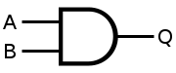

__A____ 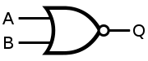

_B_____ 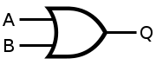

_D_____ 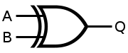

A:
A | B | Q
F | F | T
F | T | F
T | F | F
T | T | F

B:
A | B | Q
F | F | F
F | T | T
T | F | T
T | T | T
C:
A | B | Q
F | F | F
F | T | F
T | F | F
T | T | T

D:
A | B | Q
F | F | F
F | T | T
T | F | T
T | T | F

- Write equations for the below gates. Use * for AND, + for OR, ! for NOT, and () to specify order of operations. Use no other symbols.
  - Example equation: A*B
  - Equation: ___!(A+B)_______
  - Equation: ___A*!B+ B* !A___

- Draw gates which represent X=(A+B)*!C.

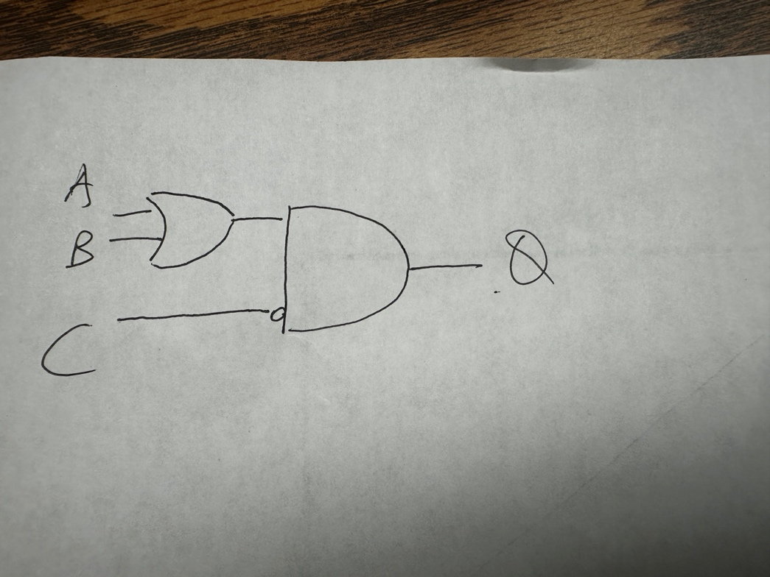

Problem 4: Debugging [13 points]

In this class, you will need to use a debugger while working on your project. In general, staff will not be able to provide adequate help in office hours if you are not able to set breakpoints in your code, step through execution line by line, and view object values during execution. Any debugging interface (an IDE like XCode or VSCode, or a terminal interface like GDB) is fine. Please read through EECS 280's Setup Tutorial and attend office hours in the first week if you need help setting up a debugger.

What debugging interface will you be using? [5]

_VSCode______________________

Configure your programming environment to compile and run the following code:

#define ARR_SIZE 5

typedef struct My_Struct {
int i;
char c;
} My_Struct;

int main() {
My_Struct my_arr[ARR_SIZE];
for(int i=0; i<ARR_SIZE; i++) {
my_arr[i].i = (i << 4) * 3 - (2 << i);
my_arr[i].c = my_arr[i].i;
}

my_arr[2].c = 'a';
return 0;
}
Provide a screenshot below of your debugging environment where execution is paused directly before my_arr[2].c = 'a' and your debugger has printed out the previous value of my_arr[2].c. You should not modify the code to insert any print statements, rather the debugger should be displaying the value. [8]
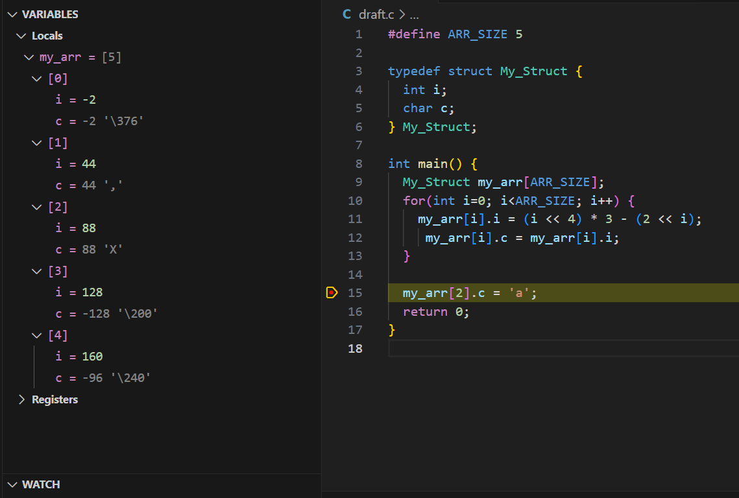
Problem 5: Lab Survey [1 point]
Everyone in your group, please fill out the lab survey which will help us form groups for later assignments. It should take ~2 minutes to complete.

